ECE411 Practicum Project

Homework #2 - Project and Team Proposal

Andy Elliott

Arsalan Sabet Sarvestani

Jelon Anderson

Sam Salin

**Project Ideas:**

***Bluetooth DAQ: (selected proposal)***

The objective here is to build a wireless sensor array with a focus on environmental monitoring, such as temperature, light level, and humidity. The device would be equipped with a bluetooth transceiver for both receiving data wirelessly on a compatible PC or mobile device. Although we have selected Bluetooth as our data transfer system, we are still in the process of de-risking the use of bluetooth with mobile devices as this requires extensive App development capabilities. The device may also include (upon further investigation) the addition of a microphone and general purpose analog inputs attached to a co-processor running an FHT (FFT) for real-time frequency analysis.

***IR Blaster Remote Control:***

This simple device would allow for the easy storing of IR remote control codes on a handheld device. The premise here is to make something that is both visually appealing and very simple to use. Utilizing the power of a modern microcontroller and several IR sensors, this device will “learn” remote codes that are fed to it and allow for the easy assignment of these codes to an array of LED backlit buttons that can then be used to blast these codes out of a variety of IR LEDs.

***Programmable Game Interface (LED):***

The purpose of this device would be to create a programmable platform that has a few button and knob inputs that allows the user to make a game which uses a 16X32 RGB LED matrix as an output. The programming would be done over either a USB connection or possibly bluetooth. We thought that implementing a pattern game as a demo of the devices capabilities would be cool. Said pattern game would allow the user to input a sequence of lights and use the knobs to control which lights on the matrix lit up. After 5 or so seconds of no input the device would then play the pattern back. Coding in clones of classics such as simon, frogger, or space invaders would be possible as a stretch goal. Another possible stretch goal would be to have a few GPIO outputs available on the PCB to allow for external interfaces, such as an audio controller or more advanced input system.

***Automated LED Streetlight:***

In order to avoid manually adjusting streetlights, in this project a set of LEDs would be controlled automatically using a Light Dependent Resistor (LDR) and Pulse Width Modulation (PWM). With PWM, the analog results from the LDR would be converted to a digital value using a microcontroller. As brightness decreases, the number of LEDs turned on would increase throughout the night. During sunrise the LEDs would begin to turn off until all LEDs are turned off as LDR detects full brightness.

**Decision Matrix:**

|  |  |  |  |  |  |  |
| --- | --- | --- | --- | --- | --- | --- |
| **Idea** | **Est. Cost** | **Difficulty / Assembly** | **Aesthetics** | **Functionality** | **Practicality / Usefulness** | **Score** |
| Automated Streetlight | 2 | 3 | 1 | 3.5 | 4 | 13.5 |
| BLE DAQ + FHT | 2 | 0 | 3 | 5 | 4 | 14 |
| Programmable Game IF | 4 | 4 | 4 | 1 | 1 | 14 |
| IR Blaster Remote | 4 | 3 | 3 | 2 | 3 | 15 |
| Laser RC Car | 2 | 1 | 4 | 1 | 1 | 9 |
| USB MIDI LED Driver | 3 | 3 | 1 | 2 | 2 | 11 |
| EEG / EKG / EMG Control System | 0 | 1 | 2 | 2 | 1 | 6 |
| Laser Shotgun | 0 | 0 | 4 | 0 | 0 | 4 |

Note:

Although we did choose the IR Blaster project using the matrix, we were all much more interested in exploring the use of a bluetooth sensor array.

**Decision Matrix Criteria:**

* Cost
  + How much will this cost to build
  + Inversely weighted for score
* Difficulty / Assembly
  + Networking
  + Available Chips
  + Etc..
  + Inversely weighted for score
* Aesthetics
  + Can this device look “good” to the user?
  + Does it sound cool?
* Functionality
  + “Technical” Criterium
  + Does it “do” a lot - technically
* Practicality
  + “Consumer” Criterium
  + Does it have attractive features?



**Bluetooth Data Acquisition System**

BluDAQ is a bluetooth-enabled environmental monitor and automation system perfect for home or business applications. Monitor any location with a user-friendly application, set alerts, or configure automated tasks. BluDAQ is equipped with several user-configurable onboard relays for controlling 120V AC and DC appliances. A built-in rechargeable battery makes wireless monitoring easy and convenient.

Features:

* Bluetooth connectivity
* Easy-to-use application for monitoring and automation
* Rechargeable built-in battery
* (2x) User-accessible SPST relays
* Programmable automation tasks
* Sensors:
  + Motion Sensor
  + Temperature Sensor
  + Humidity Sensor
  + Pressure Sensor
  + Light Sensor

Project Summary:

Utilizing an ATMega328 microcontroller, the device will gather data from a variety of sensors and make it available to the user via a serial interface or UART. The hardware component of the design is a combination automation controller and data acquisition system. The device will utilize bluetooth for live data streaming from the controller, as well as options for configuring the automation controller. Using the EEPROM in the microcontroller the device will be able to run automation tasks while not connected to the bluetooth host application, triggering the relays based off of a value from one or more sensors. The power of the device will be handled by a charge controller, allow for the device to be powered by a USB connection and manage the battery. Ideally, the software application would host a variety of operating system tasks allowing for sensors to trigger more complex actions and notifications.

**Proposed configuration:**

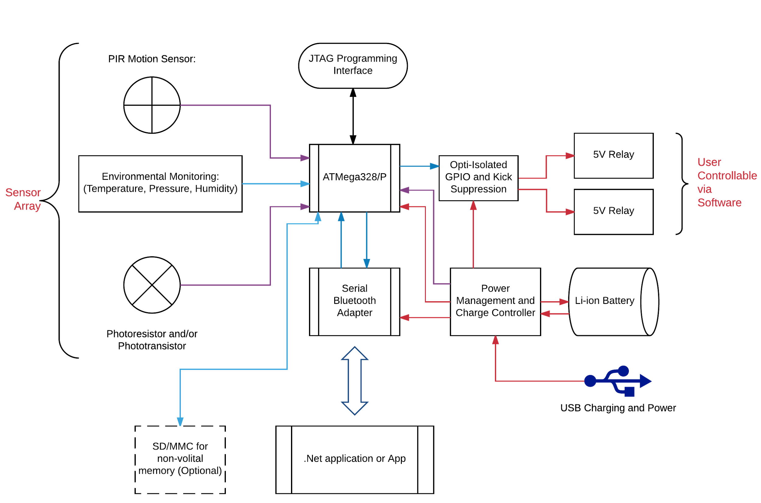

**Practicum Requirements Synopsis:**

Processing Module: ATMega328/P Microcontroller

Inputs:

* Bluetooth (Serial / UART)
* Push Button
* Sensor Array (I2C)
  + Temperature
  + Humidity
  + Pressure
* Photodiode
* PIR Motion Sensor
* Battery Monitor

Outputs / Transducers:

* Bluetooth (Serial / UART)
* LEDs
* SPST Relay